**Regular Expressions in Java**

Regular expression is simply a pattern definition using symbols for strings. We can use regular expressions to check if a string aligns with a specific pattern.

For example, all the Gmail addresses have a specific pattern.

[abcd@gmail.com](mailto:abcd@gmail.com)

a regular expression can be written to check if a given string is a Gmail address.

For testing regular expressions we will use the string method Boolean match(String regex).

**Regular Expression Symbols**

There are two types of symbols used in regex. First type is symbols used to define a single character. These can be symbols or meta characters. Second type of symbols are the quantifiers, used to define the number of the characters considering.

**First set of symbols — defines what a single character should be.**

**1.** **( . )**

Dot (.) denotes a single character.

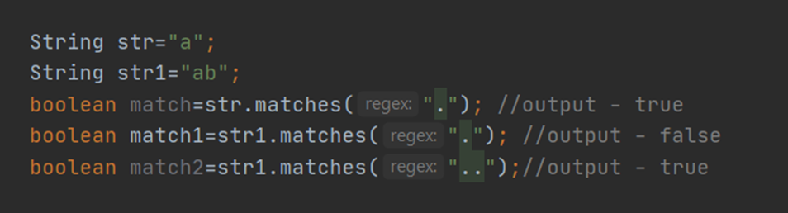

**2.** **[abc]**

Denotes a single character should be one of those inside the brackets. The character should be ‘a’ or ‘b’ or ‘c’.

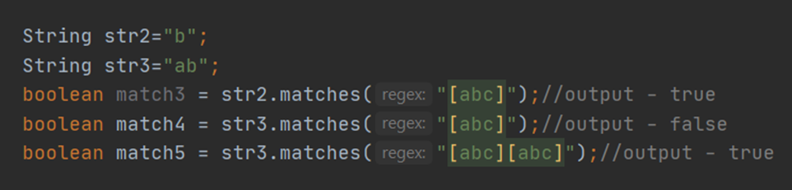

**3.** **[^abc]**

Denotes a singe character should not be one of those inside the brackets.

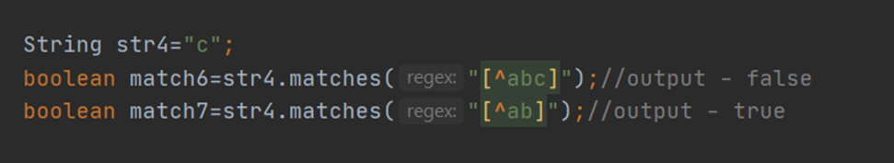

**4.** **[a-z]/[a-z1–9]**

Denotes a single character can be anything within the range defined inside the brackets. [a-z] means the character can be anything from a to z. [a-z1–9] means the character can be anything from a-z or 1–9

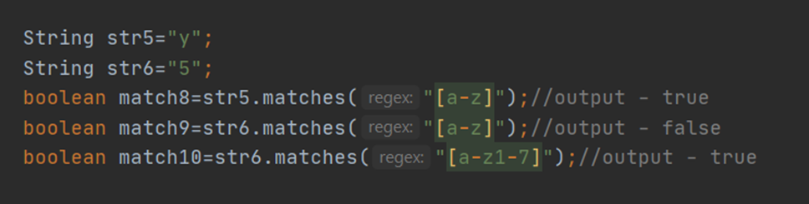

**5 .** **a|b**

denotes a single character can be a or b

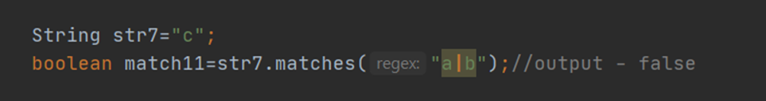

**6.** **xy**

exactly matching set of characters. This can be a single or multiple characters.

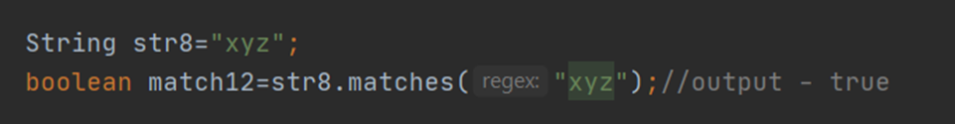

***Apart from above symbols there are meta characters which we can use to define a single character.***

**7.** **\d**

Defines a single character can be a digit between 0 and 9

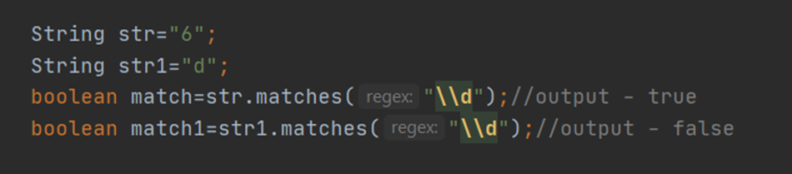

**8.** **\D**

Defines a single character can be a non-digit means Alphabet or a symbol.

**9.** **\s**

Defines a single character is meant to be a space

**10.** **\S**

Defines a single character can be anything but not a space

**11.** **\w**

Defines a single character to be an alphabet or a digit

**12.** **\W**

Defines a single character to be anything else than an alphabet or digit.

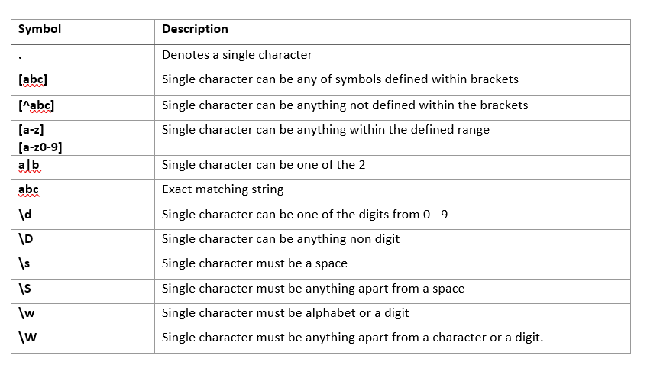

**Second set of symbols — Quantifiers**

Quantifiers are used after a character symbol. Above character symbols are defined for a single character. Using quantifiers, it can be used for multiple characters.

